

Software Design Document

for

SubScruple

Version <1.0>

Prepared by Kevin Black, Alex Sloan, Shane Bellika

Group Name: BBS teemMaets

|  |  |  |
| --- | --- | --- |
| Shane Bellika | 11639152 | shane.bellika@wsu.edu |
| Kevin Black | 11480710 | kevin.black@wsu.edu |
| Alex Sloan | 11651363 | alex.sloan@wsu.edu |
|  |  |  |
|  |  |  |

October 16, 2018

Contents

Revisions III

1 Introduction 1

1.1 Document Purpose 1

1.2 Product Scope 1

1.3 Intended Audience and Document Overview 1

1.4 Definitions, Acronyms and Abbreviations 2

1.5 Document Conventions 2

1.6 References and Acknowledgments 2

2 Overall Description 3

2.1 Product Perspective 3

2.2 Product Functionality 3

2.3 Users and Characteristics 4

2.4 Operating Environment 4

2.5 Design and Implementation Constraints 4

2.6 User Documentation 5

2.7 Assumptions and Dependencies 5

3 Specific Requirements 6

3.1 External Interface Requirements 6

3.2 Functional Requirements 6

3.3 Behaviour Requirements 9

4 Other Non-functional Requirements 10

4.1 Performance Requirements 10

4.2 Safety and Security Requirements 10

4.3 Software Quality Attributes 10

5 Other Requirements 12

Appendix A – Data Dictionary 13

Appendix B - Group Log 14

Revisions

| Version | Primary Author(s) | Description of Version | Date Completed |
| --- | --- | --- | --- |
| <1.0> | Kevin Black | Initially formatted document and created class diagram. | 10/16/2018 |

# 

# Introduction

## Document Purpose

## Product Scope

## Intended Audience and Document Overview

## Definitions, Acronyms and Abbreviations

## Document Conventions

## References and Acknowledgments

# Activity Diagrams

# Class Diagram

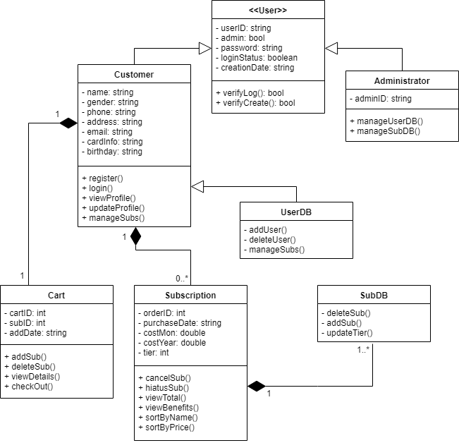

**Figure 3.1.** Class Diagram for **SubScruple**

# Sequence Diagrams